**Mini Project Report on**

BRAKE FAILURE INDICATOR CIRCUIT

**Submitted by:**

**PANKTI SHAH (17EC078)**

**Reference and Guided by:**

**SAGAR B. PATEL**

**MANTHAN MANAVADARIA**

**B.E. SEMESTER III (ELECTRONICS AND COMMUNICATION)**

**Year -2018**



**CHANDUBHAI S. PATEL INSTITUTE**

**OF TECHNOLOGY, CHANGA-388421**.

ABSTRACT:

Brake failure indicator circuit constantly monitors the condition of the brake and gives an audio-visual indication. When the brake is applied, the green LED blinks and the piezoelectric buzzer beeps for around one second if the brake system is intact. If the brake fails, the red LED glows and the buzzer stop beeping. The circuit will work only in vehicles with negative grounding. It also gives an indication of brake switch failure. In hydraulic brake systems of vehicles, a brake switch is mounted on the brake cylinder to operate the rear brake lamps. The circuit uses an op-amp IC [CA3140](https://www.intersil.com/content/dam/Intersil/documents/ca31/ca3140-a.pdf) (IC2) as voltage comparator and timer [NE555](http://electronicsforu.com/resources/learn-electronics/555-timer-working-specifications) (IC3) in monostable configuration for alarm. Voltage comparator IC2 senses the voltage level across the brake switch. Its non-inverting input (pin 3) gets half the supply voltage through potential divider resistors R3 and R4 of 10 kilo-ohms each. The inverting input (pin 2) of IC2 is connected to the brake switch through diode D1, IC 7812 (IC1) and resistor R2. It receives a higher voltage when the brake is applied.

COMPONENTS LIST:-

1. ICs (7812,CA 3140,NE555)

2. Resistors (10k,100k,470k,470)

3. Electrolytic capacitors (1000u 25V,100u 25V,10u 25V)

4. Ceramic capacitors (0.01uF,0.02uF)

5.Diodes(1N4007)

6.Led(green,red)

7.Piezobuzzer

8.Brake switch

9.Connecting wires

10.Power supply(9V,12V)

CIRCUIT DIAGRAM:

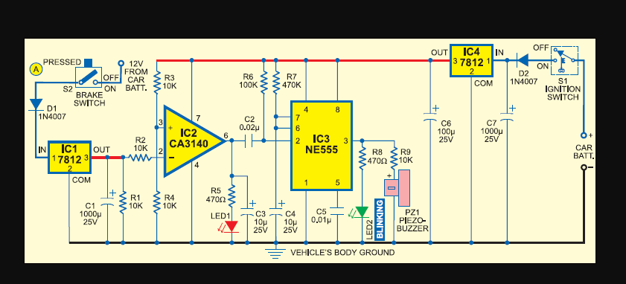

WORKING OF CIRCUIT:-

The circuit uses an op-amp IC [CA3140](https://www.intersil.com/content/dam/Intersil/documents/ca31/ca3140-a.pdf) (IC2) as voltage comparator and timer [NE555](http://electronicsforu.com/resources/learn-electronics/555-timer-working-specifications) (IC3) in monostable configuration for alarm. Voltage comparator IC2 senses the voltage level across the brake switch. Its non-inverting input (pin 3) gets half the supply voltage through potential divider resistors R3 and R4 of 10 kilo-ohms each. The inverting input (pin 2) of IC2 is connected to the brake switch through diode D1, IC 7812 (IC1) and resistor R2. It receives a higher voltage when the brake is applied.

Normally, when the brake is not applied, the output of IC2 remains high and the red LED (LED1) glows. The output of IC2 is fed to trigger pin 2 of the monostable through coupling capacitor C2. Resistor R1 is used for the input stability of IC2. IC1 and C1 provide a ripple-free regulated supply to the inverting input of IC2.

IC3 is wired as a monostable to give pulse output of one second. Timing elements R7 and C4 make the output high for one second to activate the buzzer and LED2. Usually, the trigger pin of IC3 is high due to R6 and the buzzer and LED2 remain ‘off.’

When the brake pedal is pressed, pin 2 of IC2 gets a higher voltage from the brake switch and its output goes low to switch off the red LED. The low output of IC2 gives a short negative pulse to the monostable through C2 to trigger it. This activates the buzzer and LED2 to indicate that the brake system is working. When there is pressure drop in the brake system due to leakage, LED1 remains ‘on’ and the buzzer does not sound when the brake is applied.

CONSTRUCTION AND TESTING:-

The circuit can be assembled on any general-purpose PCB or perforated board. Connect point A to that terminal of the brake switch which goes to the brake lamps. The circuit can be powered from the vehicle’s battery.

The circuit requires well-regulated power supply to avoid unwanted triggering while the battery is charging from the dynamo. IC4, C6 and C7 provide regulated 12V to the circuit. The power supply should be taken from the ignition switch and the circuit ground should be clamped to the vehicle’s body. A bicolour LED can be used in place of LED1 and LED2 if desired.

SCHEMATIC VIEW:

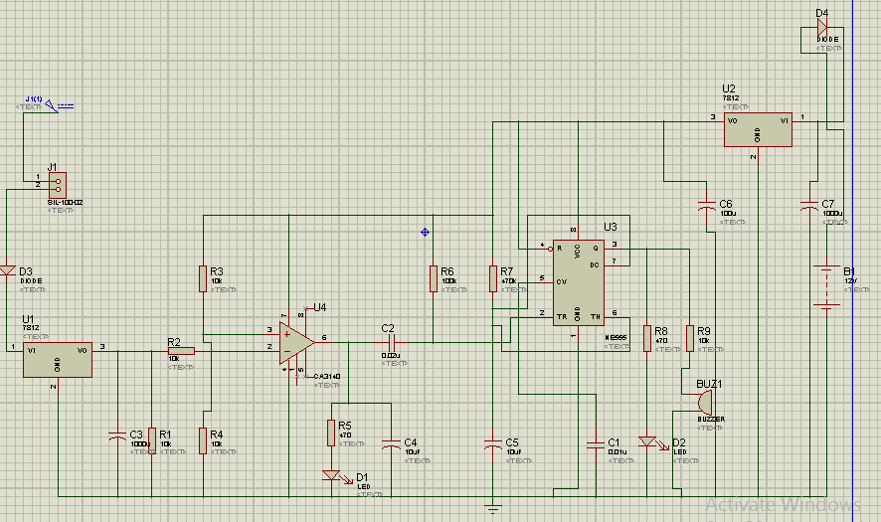

ARES VIEW:



3D VIEW:

